User Manual Guide

NOTE:- Once you receive the packaged box, please check the list of devices mentioned in the user guide and then follow the steps to install each device.
- Items delivered in the package are: -
- Raspberry Pi 5
- Camera
- Buzzer Alarm
- FFC Ribbon wire
- Power supply cable
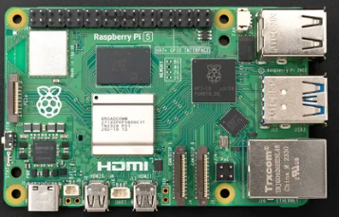 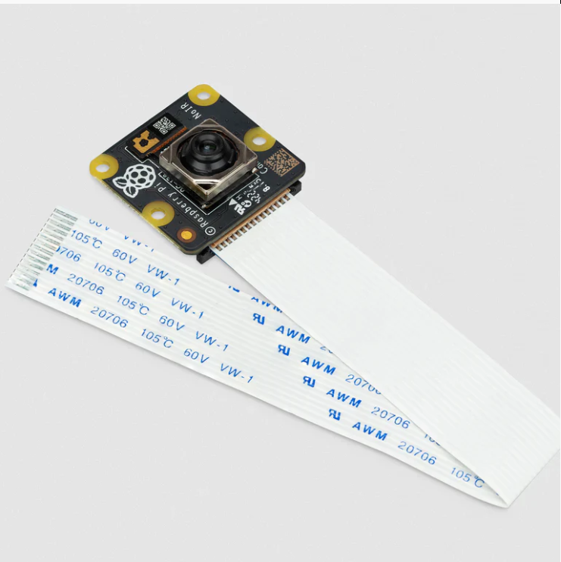
Raspberry Pi 5 Camera
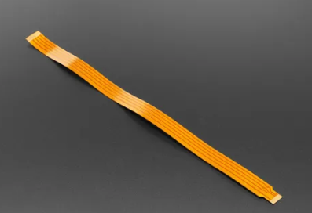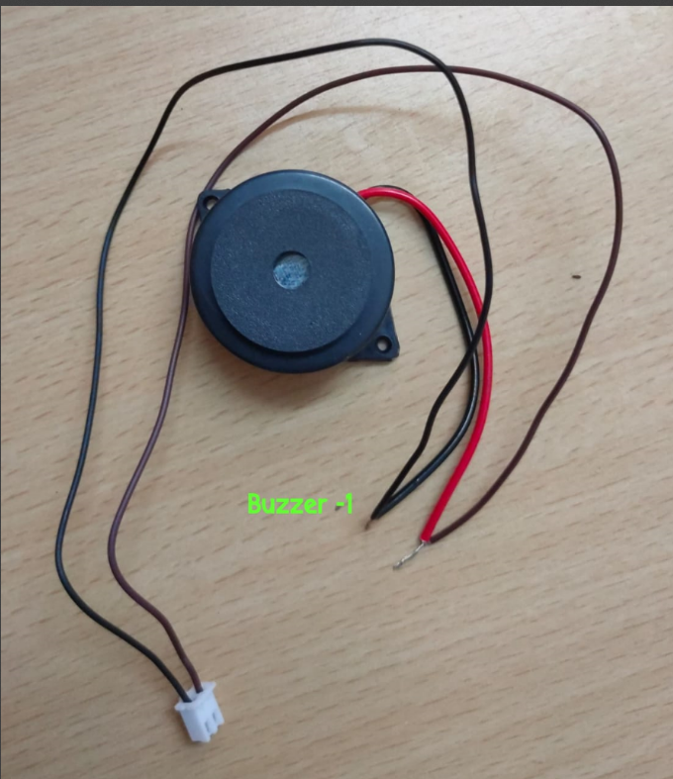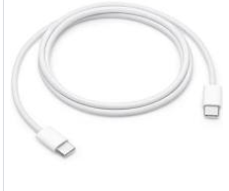
FFC Ribbon wire Buzzer Alarm Power Supply mobile cable

- To make Sleep Alert device proper functioning please follow below instructions: -
- Connect one end of FFC Ribbon wire to Raspberry Pi 5 to appropriate port (CSI Port) and other end of FFC Ribbon wire to Camera Module 3.
- Connect Buzzer Alaram device to appropriate pin of Raspberry Pi.
- Connect power supply 5.1V 5A to Raspberry Pi from one end and supply power from Mobile connector of Car using USB Cable.
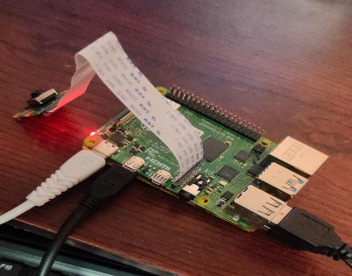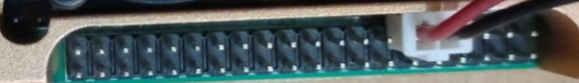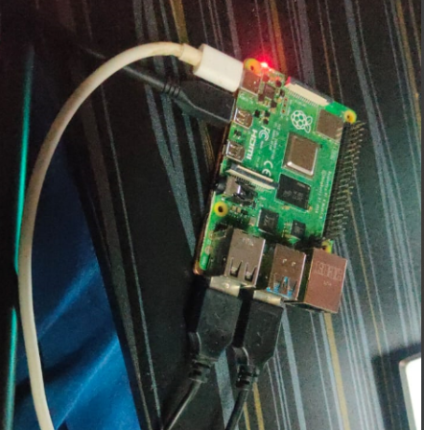
Assembled Picture Buzzer Alaram PIN connected. Power Supply connected

- Placement of Raspberry Pi and Buzzer Alaram:

- Keep the Raspberry Pi at appropriate place with power supply connected. There should be open top for air circulation and getting ample cooling effect.
- Also place and stick it in such a way so that there is no jerk observed while driving.
- Best place will be near gear box from where power supply will be easy from mobile connector.
- Also place Buzzer Alaram beside Raspberry Pi 5.
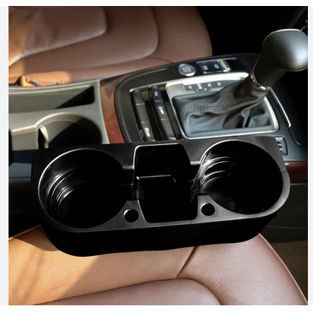
Space near Gear Box
4. Placement of camera.
- Install and place the camera in front of driver either on Back Mirror or On Car Desk. Make sure, camera should be pointed to driver's face with angle in the range of 30º to 45º.
- Adjust the wiring so that it doesn't disturb driver and there should not be stretching of wire.
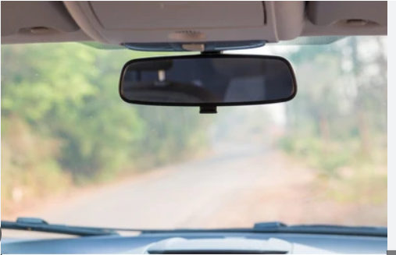
Back Mirror where Camera module 3 can be placed.
5. Check functionality of device.
- Prior to supply Power, check all wire connection and then switch on Power supply from car by igniting/starting the engine.
- Switch ON Raspberry Pi device and wait for 4-5 min to listen to the beep sound. If you get beep sound for 5 sec, it means device is working else check your connectivity of everything including power supply 5.1v 5 A.

6. Working condition.
- Once your device is working fine, it will first detect the face of the driver and then detect eyes of the driver. So, if there is no driver, no face and no eyes will be detected. Hence, no beeping sound.
- Whenever your eyes get closed, you will get beeping sound for 15 sec. After that it will turn off once your eyes are open.
- Anytime, if you get a continuous beeping sound for 1 min, it means the device is hanged and you need to switch OFF the power supply and then switch ON it to bring it into working condition. (Rare case).

6. Limitations:
- Distance between Camera and Driver’s face should be 1meter -1.5 meter for proper working.
- Placing of camera is important and it should directly peep into eyes of driver.
- In case of driving at night, try to arrange some light (dim light /led light) inside driver’s cabin. (door light will also work).
- For proper functioning, appropriate amount of power supply should be provided. Ignited Engine is sufficient for proper working.
7. Support and replacement: -
If you are facing any issue with Raspberry Pi, Buzzer or Camera, re-assure the steps mentioned in User Manual Guide. If the issue is not resolved, contact technical team of our company TRINADE AI TECHNOLOGIES PVT LTD and within 24 hours, you will get proper assistance to resolve your issue. In case of fault in device, you will get replacement of entire devices within 14 days with proper set-up done from our team. (As per Terms & Conditions and Policy of Trinade).

